**Item Layouts and Answer Variations Guide**

Published January 3, 2015

Prepared by the American Institutes for Research®

Table of Contents

About Layouts 1

Font Sizes & Measurements in this Document 2

About Stimuli Types 2

About Item Types and Response Areas 3

Elicited Response 3

Selected Response Items 3

Short & Extended Answer Items 5

Edit Task Items 6

Match Items 7

Hot Text Items 7

Table Items 8

Equation Items 8

Cloze Items 9

Scaffolding Items 10

Scratch Pad Items 11

Grid Items 11

Simulation Items 12

Item Layouts 13

Layout 1 13

Layout 2 14

Layouts 3 and 4 14

Layout 5 15

Layout 6 15

Layout 8 16

Layout 11 16

Layout 12 17

Layout 13 18

Layout 14 19

Layout 15 19

Layout 16 19

Layout 17 20

Layout 21 21

Layout 22 22

Layout 23 23

Layout 24 24

Layout 25 25

Layout 26 26

Layout 27 27

Layout 33 28

Layout WAI 31

Best Practices 32

Best Practices 1: Use Appropriate Layout (Part I) 32

Best Practices 2: Use Appropriate Layout (Part II) 32

Best Practices 3: Use Small Images for Response Options 33

Best Practices 4: Separate Text from Graphics 33

Best Practices 5: Use Caution When Working with Tables 34

Best Practices 6: Use Caution When Adjusting Spacing 34

Best Practices 7: Use Appropriate Tags 34

Best Practices 8: Avoid Underlining Text 35

Best Practices 9: Align Images in Response Options 35

Cover Page Layouts 36

Cover Page 1 36

Cover Page 2 37

Cover Page 3 37

Cover Page 4 38

Cover Page 5 38

Cover Page 6 39

Maximum Image Dimensions 40

# About Layouts

Layouts in the Item Tracking System (ITS) determine the orientation of the stimulus and items as they appear in the Student Testing Site or any other application that uses the TDS Blackbox. Some layouts may accommodate multiple items, but they can only accommodate one stimulus. Other layouts may consist of one or more items *without* a stimulus. The type of layout you select for a test screen depends on the following factors:

* Item Type
* Number of Items
* Association with a stimulus
* Stimulus Type
* Item Bank

The text in item stems, response options, and passages is always left-aligned, but the area containing it may not be. For example, a left-aligned response option could appear in the center of the screen if it is part of a horizontal or stacked Multiple-Choice item layout in which the group of response options is centered.

Many single-item layouts are limited to a maximum width of 40 ems to maintain consistency between small and large monitors. They also have a minimum width of 200 pixels.

|  |  |
| --- | --- |
|  | **Layouts 1, 11, 13, 17, 21–27 do not follow this rule:**   * Layouts 1, 13, and 22 do not have a maximum width. * Layouts 11, 17, 21, and 23–27 fill 100% of the screen because these layouts are divided into two scrollable sections. |

## Font Sizes & Measurements in this Document

Unless otherwise indicated, measurements in figures use “em” units, which correspond to the width of a single “M” character. This unit is used for consistency purposes to account for instances where zoom is applied. The normal zoom level of text is 1.2 ems (about 12 pixels). Zoom text multiplies the base level of the font. There are 5 zoom levels: Level 0 (default) through 4. The figure below displays the zoom levels and their equivalent pixel heights on screen.

This document does not use point sizes, as points are a measurement strictly for the print medium and can vary in size from one screen to another.

Zoom Levels

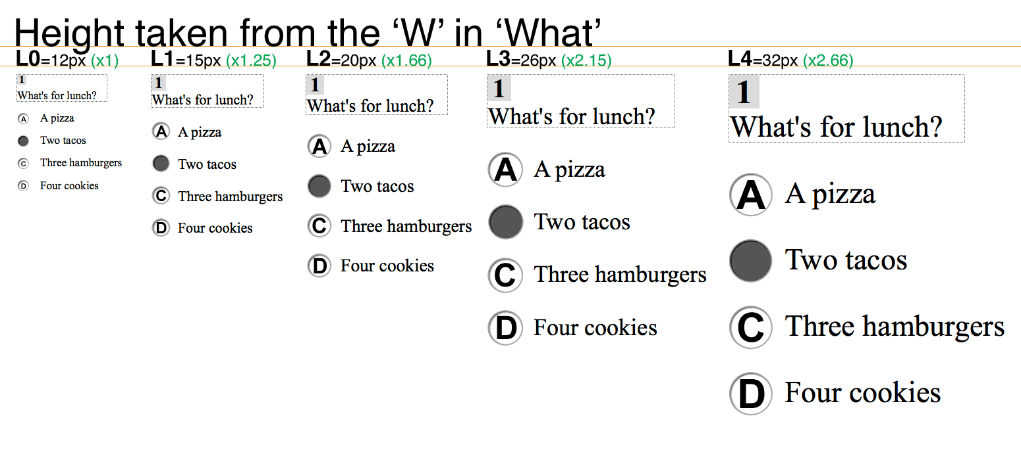

## About Stimuli Types

A stimulus may be associated with one or more items. When items are part of a layout which includes a stimulus, they will all have the same structure: stem followed by response. The type of stimulus also determines which layout you should use. Stimuli may consist of the following:

* Reading Passage
* Illustration/Graphic/Table/Chart
* Audio/Video Recording
* Animation

## About Item Types and Response Areas

Most items consist of a stem and a response area (except Cloze items, which combine the stem with the response area). Stems tend to be homogenous across item types, but the response areas vary greatly. Each item type may be used with any available layout. However, certain layouts are not recommended for Grid items, Scratch Pad items, and Simulation items, because these items have response areas with a fixed width.

### Elicited Response

For Elicited Response items, an on-screen widget indicates instances of recording and playback. The widget’s appearance depends on its current state.

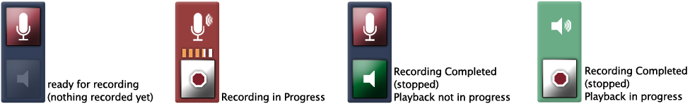

### Selected Response Items

There are several types of Selected Response item types, including Multiple-Choice, Multi-Select, Picture-Click, and Evidence-Based Selected Response items.

#### Multiple-Choice and Multi-Select items

Multiple-Choice and Multi-Select items use the same item layouts. There are three item layout variations for these item types: Vertical, Stacked, and Horizontal.

Clockwise from Top Left: Vertical, Stacked, Horizontal

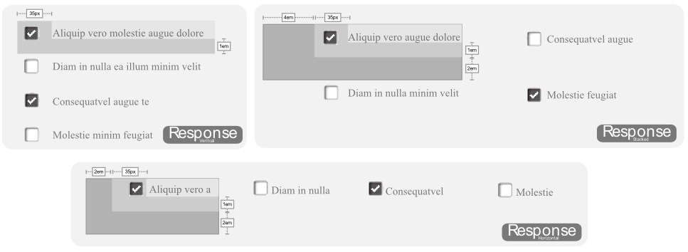

#### Picture-Click Items

Picture-Click items display graphics for response options, rather than text. These item types use the same variations as standard Multiple-Choice item types (Stacked, Vertical, and Horizontal).

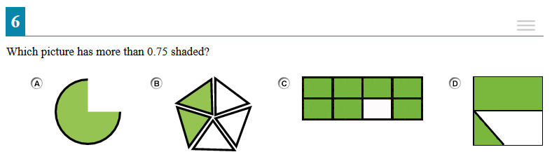

#### Evidence-Based Selected Response (EBSR) Items

EBSR items combine two sets of stems and response options into a single item. Unlike Multiple-Choice and Multi-Select item types, EBSR items cannot be displayed in horizontal or stacked layouts. EBSR items can only display response options vertically.

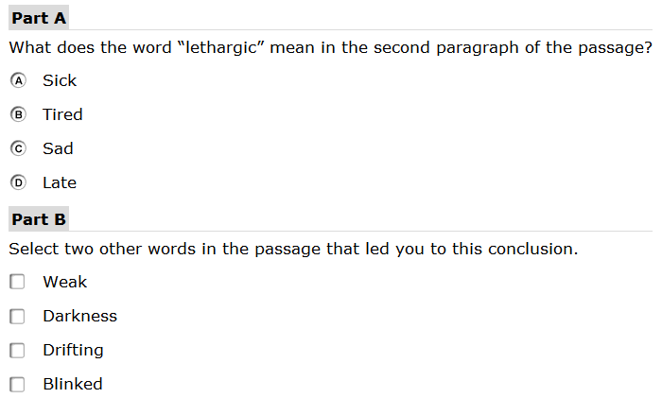

### Short & Extended Answer Items

The response areas for Short Answer and Extended Answer item types essentially have the same appearance. Extended Answer response areas accommodate more text than Short Answer response areas. You can configure the character limit for both item types.

Short Answer Item

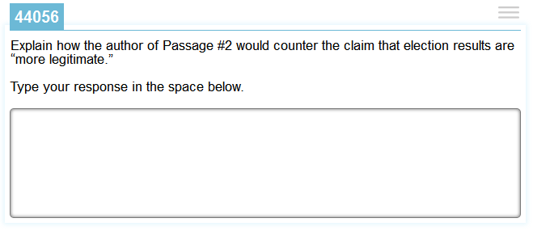

#### HTML Editor Items

HTML Editor items are a type of written response item that include a Javascript text area designed to allow for rich text formatting. It is as wide as its container, which is normally about 481 pixels wide in the default layout. HTML Editor items typically use Layout 1.

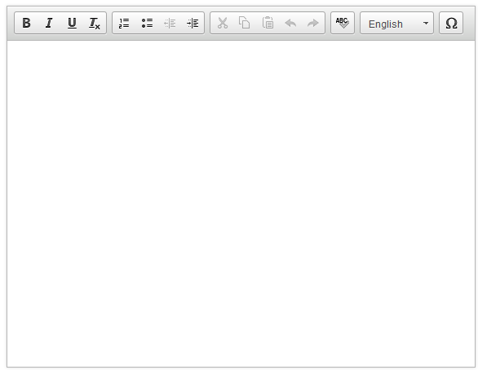

### Edit Task Items

The Edit Task item response area consists of a section of text containing highlighted interactive words that students can modify via a modal window. Edit Task items require students to enter the response in a text box. Edit Task Choice items require students to select a response from a options in a drop-down list. The interactive text cannot exceed 28 characters (including spaces) for Edit Task Choice items, due to the width of the drop-down list. The text passage can be any size, as it uses 100% of the window’s width.

Edit Task Item

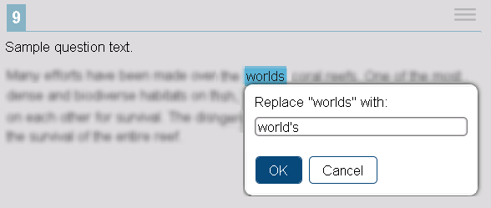

Edit Task Choice Item

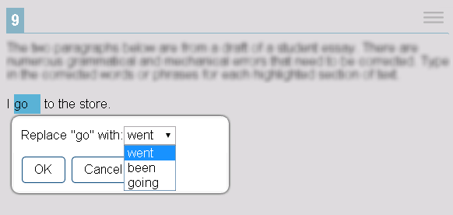

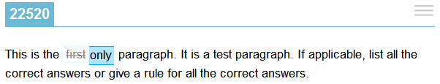

### Matching Items

The response area for Match items may appear in Match format or Table Match format. The latter format is more common for this item type. Both formats use Layout 8. Match items in Match format have a minimum width of 375 pixels (22 ems) at default zoom level.

|  |  |
| --- | --- |
| Match Format | Table Match Format |

### Hot Text Items

The response area for Hot Text items consists of a section of text containing interactive words or phrases that students can either select (highlight) by clicking or rearrange by clicking and dragging.

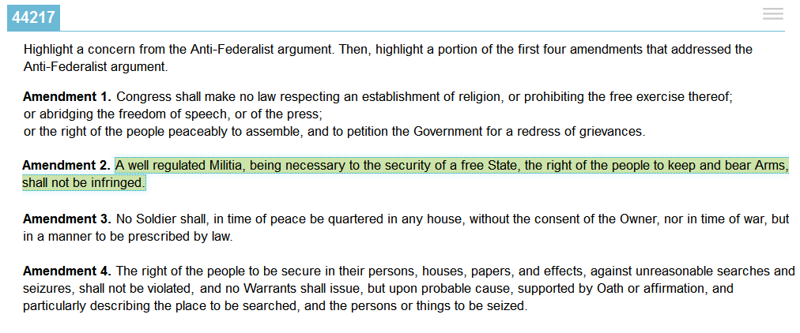

### Table Items

The Table item response area consists of a table with cells in which students may enter text.

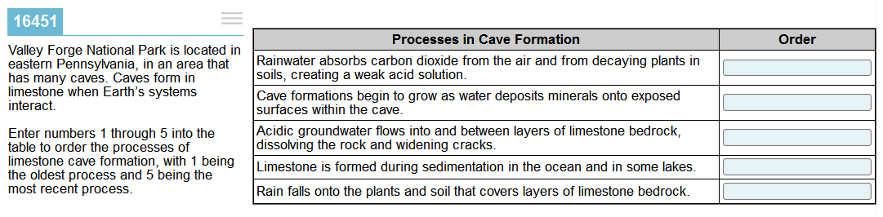

### Equation Items

The Equation item response area consists of one or more entry boxes and an on-screen keyboard containing mathematical characters. These items are 769 pixels wide or use 100% of the available response area width (whichever is smaller). The default height is 254 pixels.

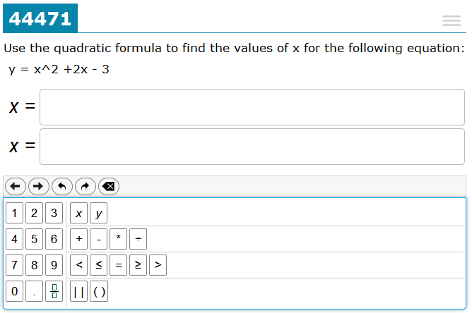

### Cloze Items

The response area for Cloze item types differs slightly from other item types because it is combined with what is normally considered to be the item stem.



Cloze responses can include a full QWERTY keyboard, an alphabetically ordered keyboard, a partial keyboard, or no on-screen keyboard (requiring students to use the actual keyboard).

|  |  |
| --- | --- |
| QWERTY Keyboard | Alpha Keyboard |

Partial Keyboard



### Scaffolding Items

Scaffolding items use Layout 25, occupying 70% of the screen on the right side. Scaffolding item response areas consist of interactive cards and audio cues. Each card is 170 pixels wide by 204 pixels tall at default zoom level. The images in the cards must be within these measurements and should be the same size for all response options. Only two to three response option cards are allowed for these item types, but this may change in the near future.

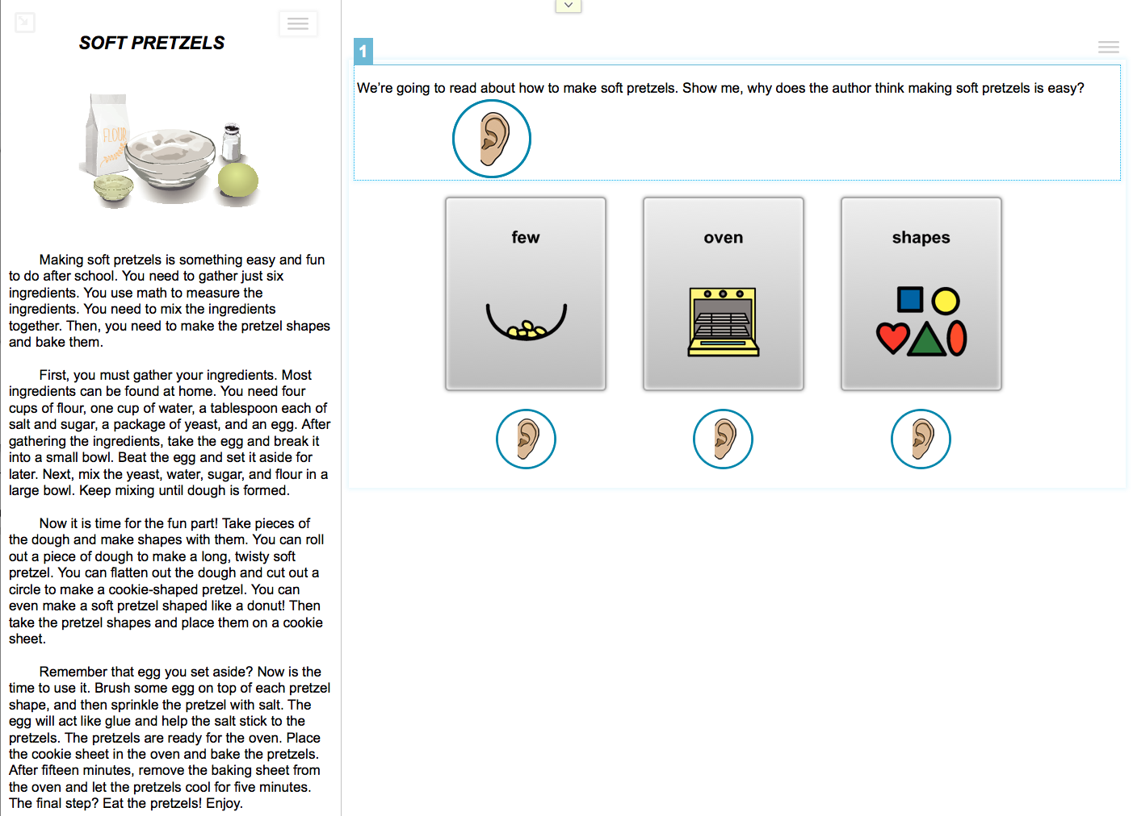

### Scratch Pad Items

The Scratch Pad item response area consists of a canvas in which students can create drawings. You should only use these items in Layouts 13, 21, and 22 because their width is not flexible.

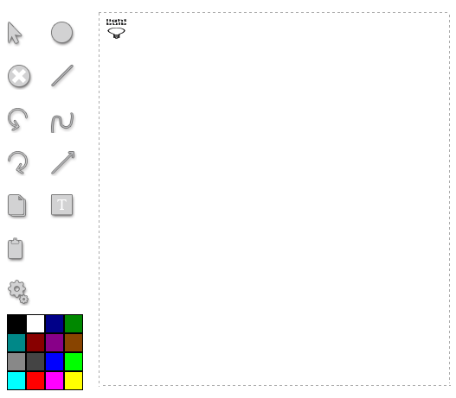

### Grid Items

The Grid item response area consists of a grid in which students can select objects, place objects, and construct graphs. Each grid area is usually 550 pixels tall by 650 pixels wide, depending on the layout (in layout 21 the grid is 465 x 575). Because the width of Grid items is not flexible, you should only use these items in Layouts 13, 21, and 22.

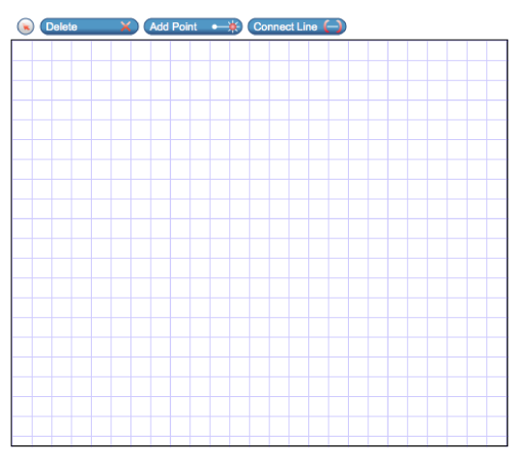

### Simulation Items

The response area for Simulation items consists of one or more input tools, an interactive animation, and an output table that populates with data when students run animations. These items may also function like stimuli and be associated with other items. Each Simulation response area is 6500 pixels tall, and the width is determined by the layout. Simulation items can only be used in Layouts 28, 29, 30, and 31.

* In Layout 28, the item occupies 70% of the screen’s width, 90% when expanded.
* In Layout 29, the item occupies 38% of the screen’s width, 90% when expanded.
* In Layout 30, the left column is 300 pixels and the Simulation uses the remaining width of the screen on the right side.
* In Layout 31, the item occupies 100% of the screen’s width.

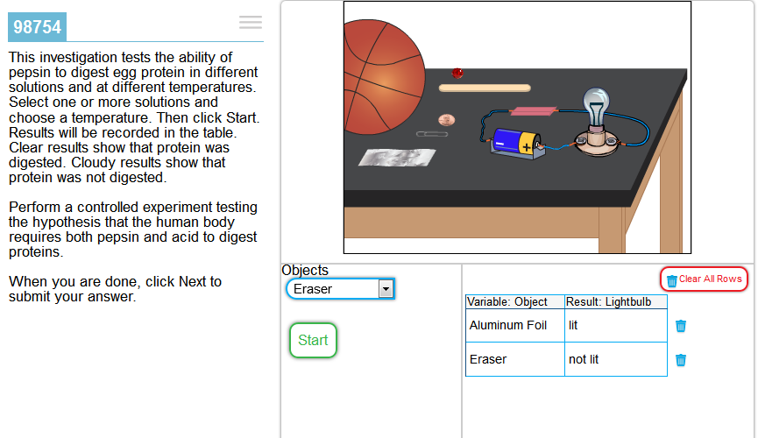

# Item Layouts

This section provides sample diagrams for each layout. The captions for these diagrams follow the format “Layout Number: Item Type.” This does not mean that the corresponding layout is used exclusively for that item type; it simply indicates what item type is used in the sample.

## Layout 1

Layout 1 does not have a maximum width.

Layout 1: Elicited Response

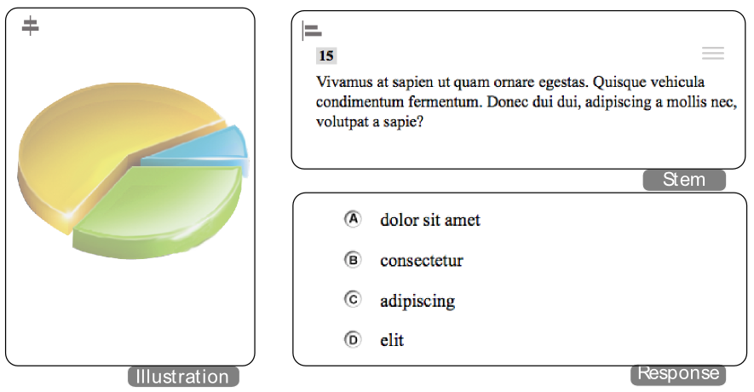

## Layout 2

Layout 2: Vertical Multiple-Choice Item

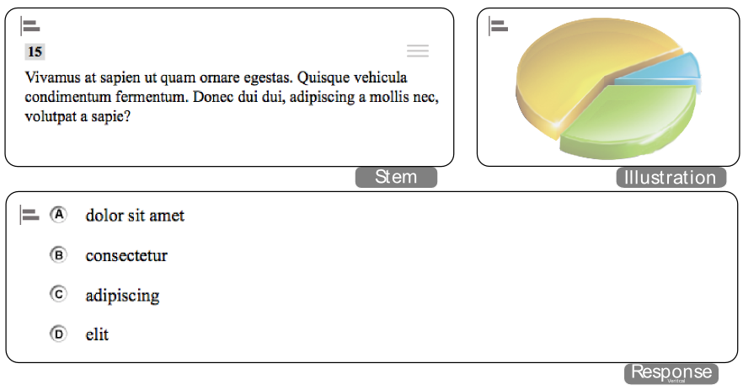

## Layouts 3 & 4

Layout 3 and Layout 4 are essentially the same layout. Original specifications called for varying percentages for the split between left and right sides of the layout, but this created an undesirable effect in the item content.

Layout 3: Vertical Multiple-Choice Item

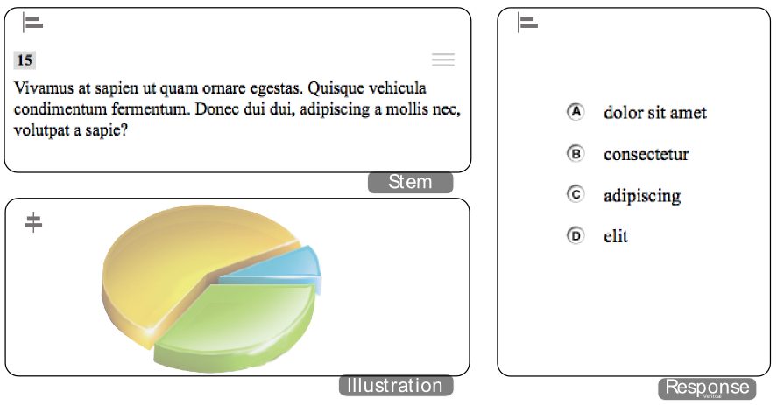

## Layout 5

Layout 5: Horizontal Multiple-Choice Item

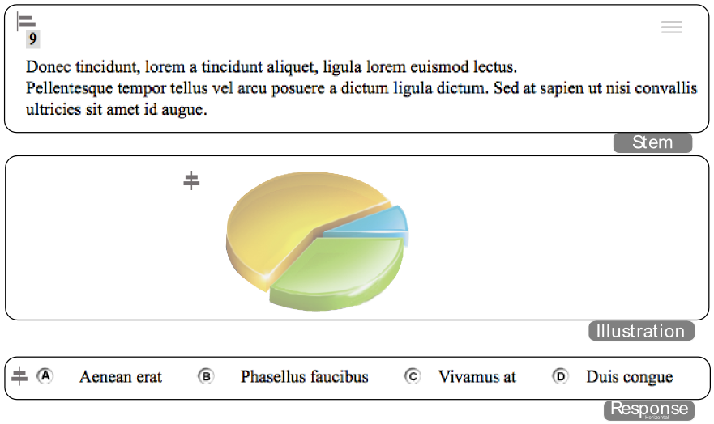

## Layout 6

Layout 6: Horizontal Multiple-Choice Item

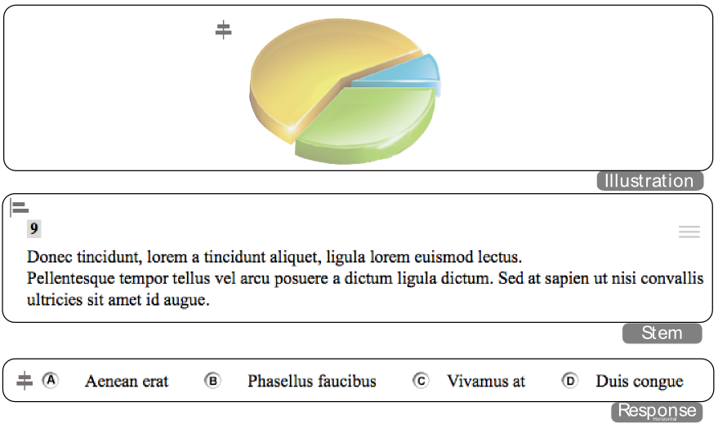

## Layout 8

Layout 8: Stacked Picture-Click Item

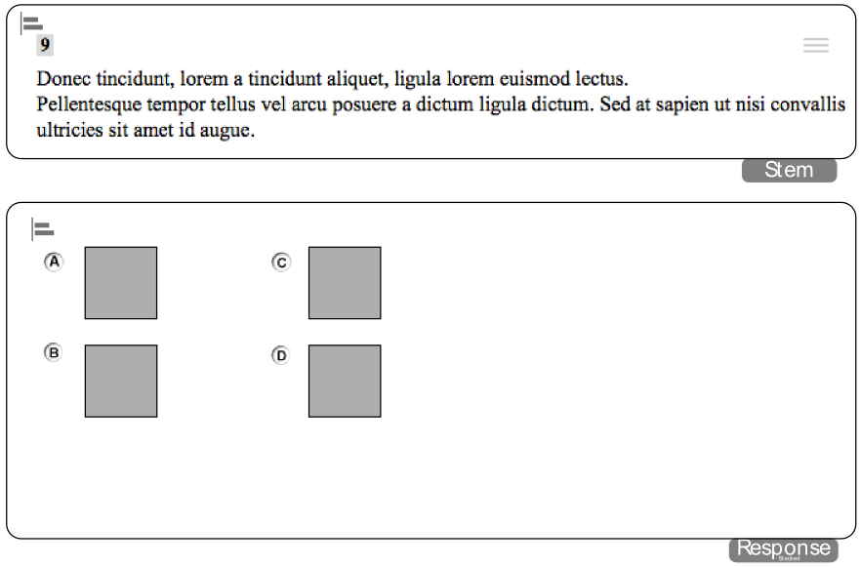

## Layout 11

Layout 11 has been discontinued. This layout occupies 100% of a user’s screen, dividing it 60/40 horizontally between the passage and sets of questions.

|  |  |
| --- | --- |
|  | For all new split-panel layouts, please use Layouts 17 and up. |

## Layout 12

Layout 12: Extended Answer Items

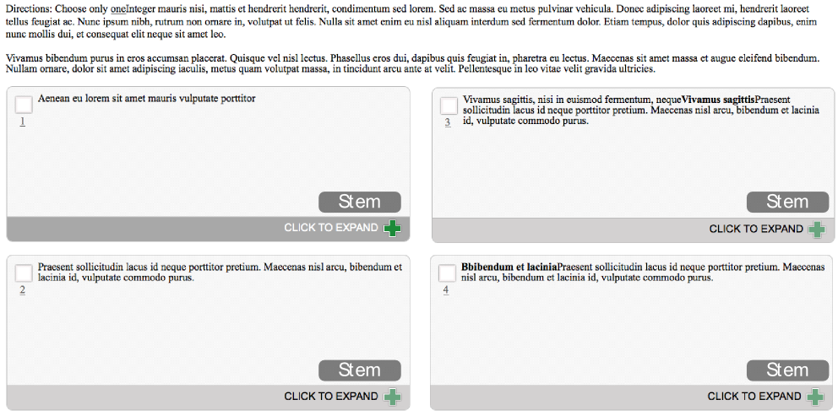

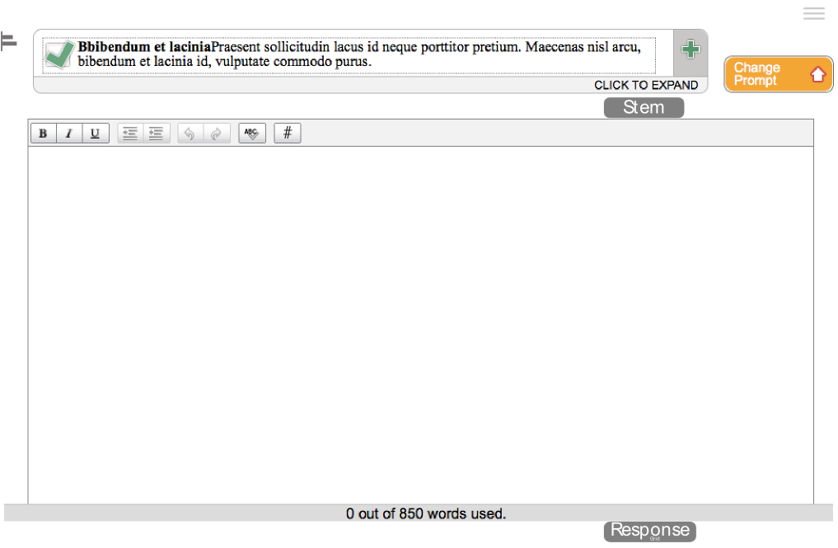

## Layout 13

Layout 13 does not have a maximum width. The grid component in this layout is 550 pixels tall by 650 pixels wide.

Layout 13: Grid Item

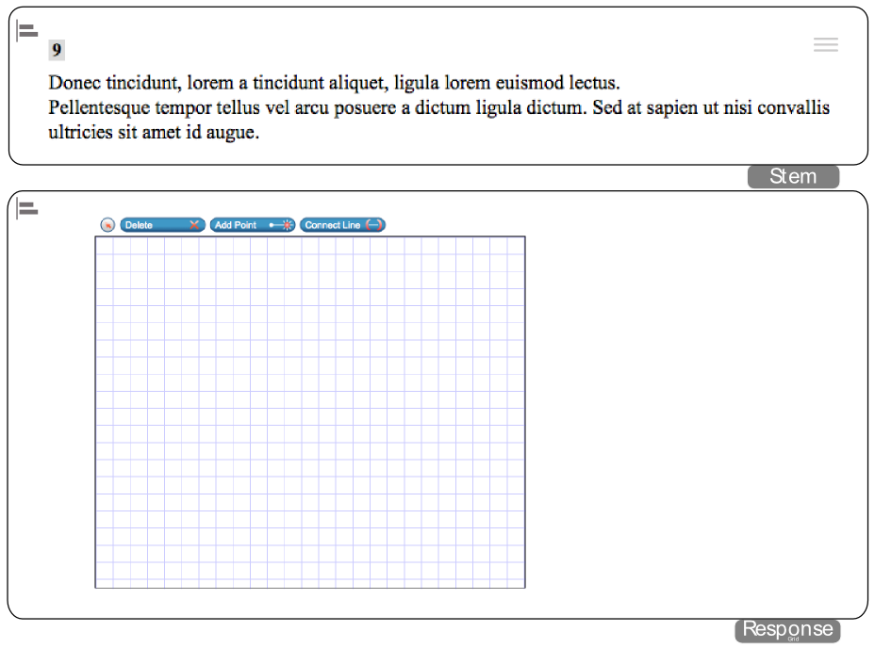

|  |  |
| --- | --- |
|  | This layout is only to be used with Grid and Scratchpad items. |

## Layout 14

Layout 14: Cloze Item

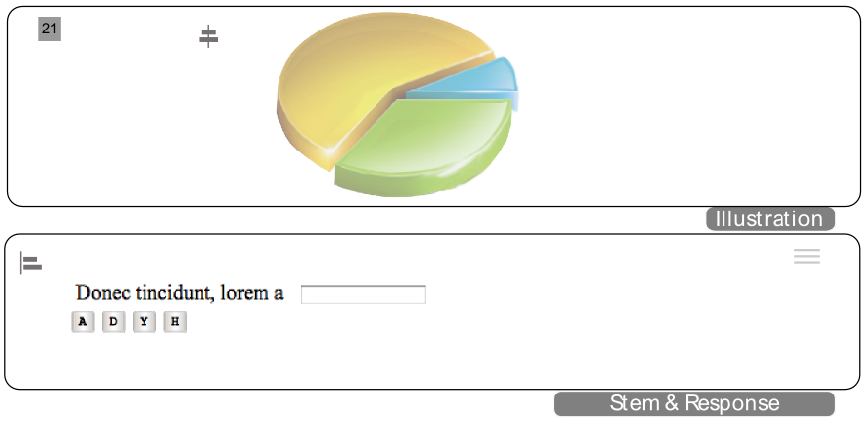

## Layout 15

Layout 15: Cloze Item

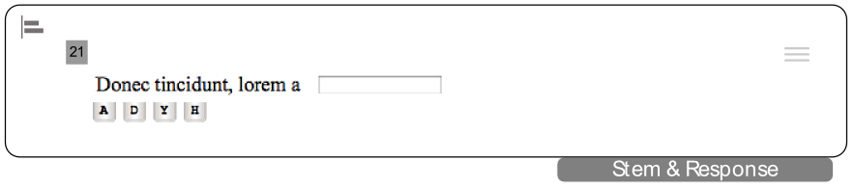

## Layout 16

Layout 16: Cloze Item

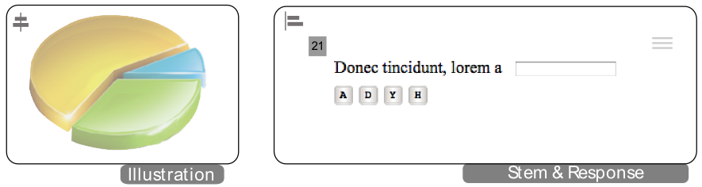

## Layout 17

Layout 17 occupies 100% of a user’s screen, dividing it 60/40 horizontally between a passage and sets of items. Layout 17 replaces Layout 11 and can contain any combination of answer variations. **On a smaller monitor at default zoom level, the item column in Layout 17 would require a horizontal scroll bar to accommodate Grid, Simulation, or Scratch Pad items.**

Layout 17: Multiple Item Types

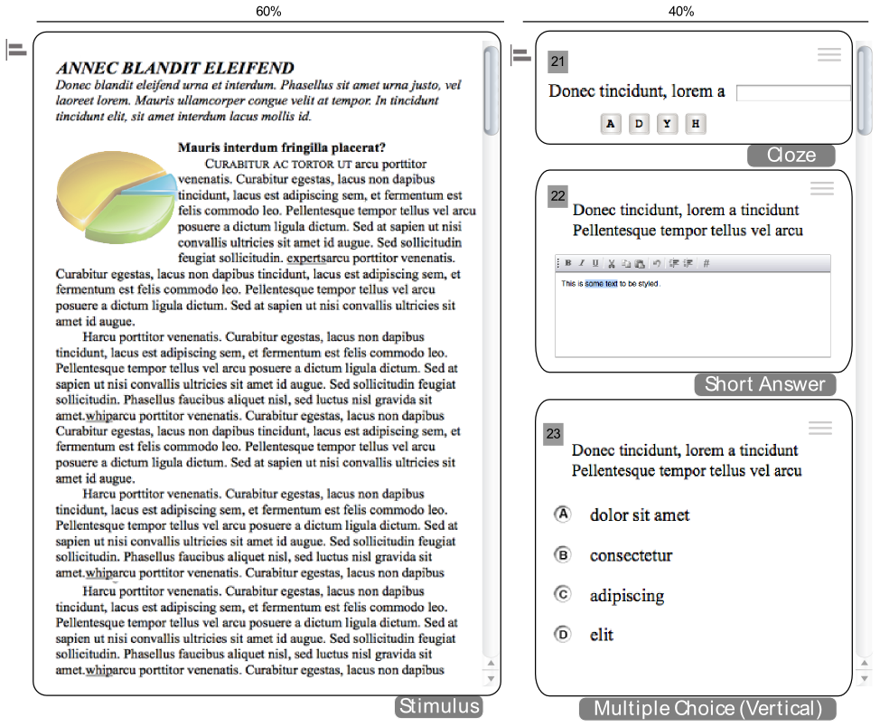

## Layout 21

Layout 21 occupies 100% of a user’s screen, dividing it 40/60 horizontally between a passage and sets of items. There is slightly less white space, or padding, between the left and right edges of each major column (10 pixels on each side instead of the normal 20 pixels). **On a smaller monitor at default zoom level, the item column in Layout 21 would require a horizontal scroll bar to accommodate Grid, Simulation, or Scratch Pad items.**

Layout 21: Multiple Item Types

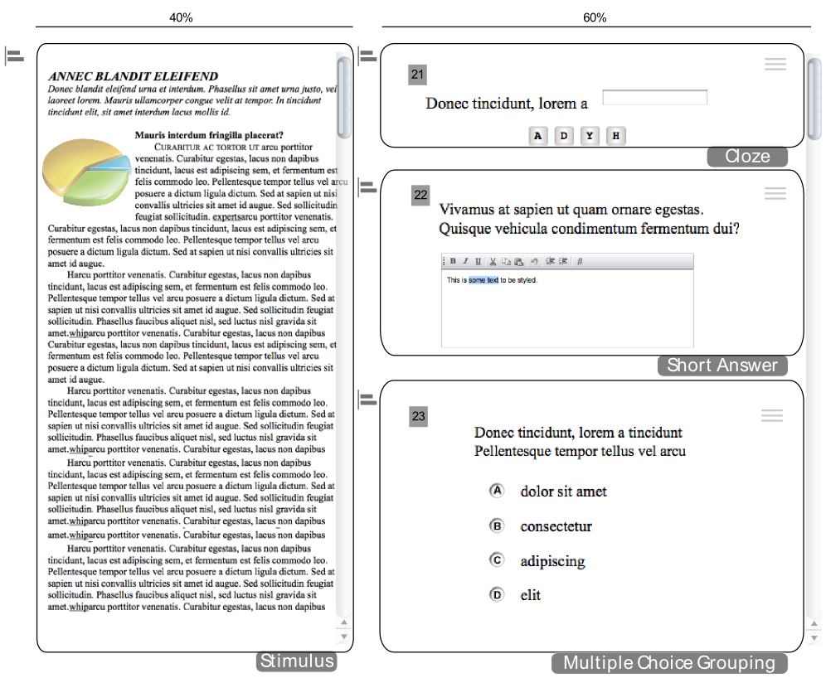

## Layout 22

Layout 22 does not have a maximum width. The grid component in this layout is 550 pixels tall by 650 wide. The stem section is 17 ems wide.

Layout 22: Grid Item

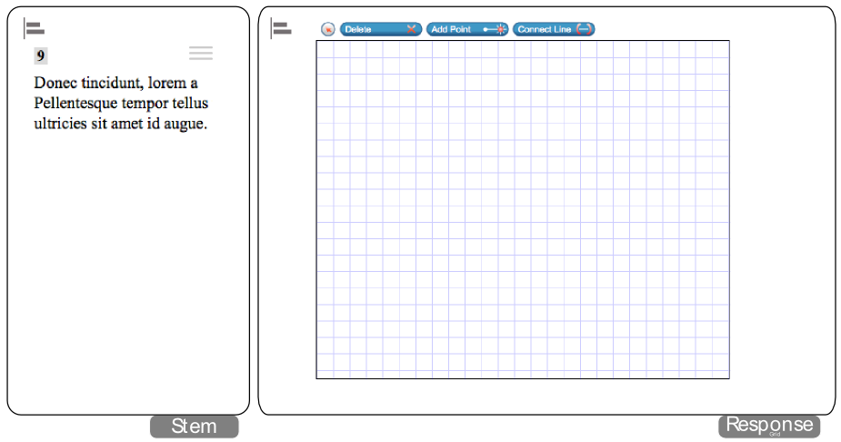

|  |  |
| --- | --- |
|  | This layout is only to be used with Grid and Scratchpad items. |

## Layout 23

Layout 23 occupies 100% of a user’s screen, dividing it 40/60 vertically between a passage and sets of items.

Layout 23: Multiple Item Types

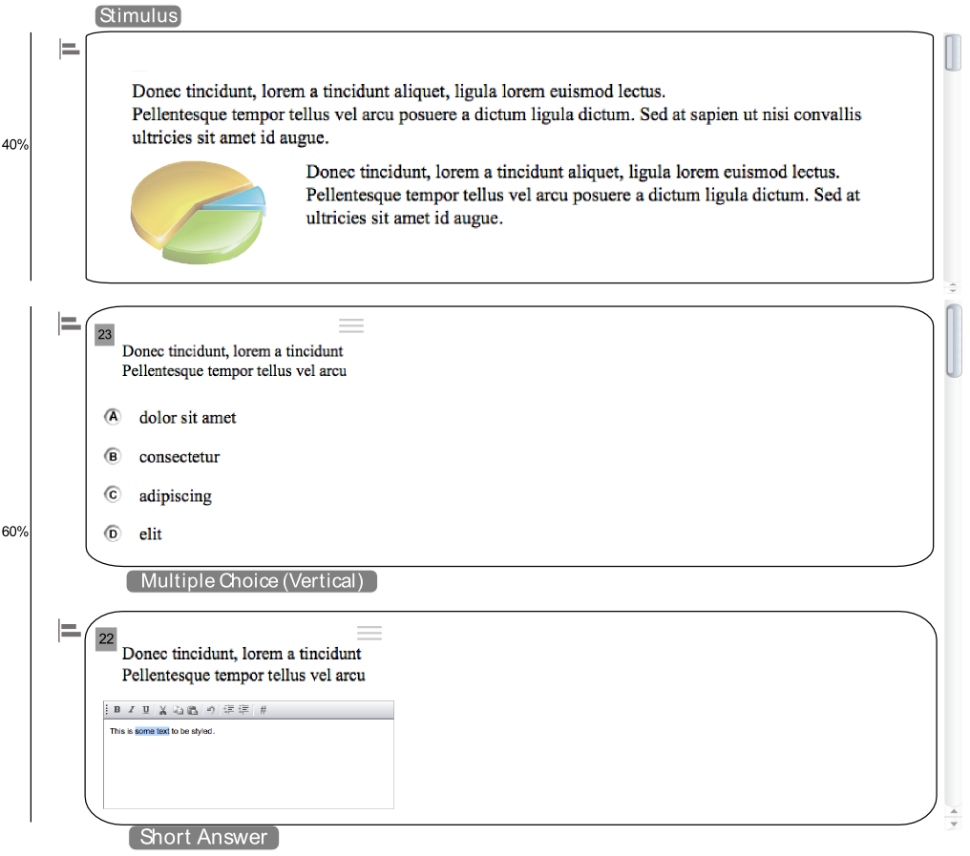

## Layout 24 & 29

Layout 24 occupies 100% of a user’s screen, dividing it 38/62 horizontally between a passage and sets of items. There is slightly less white space, or padding, between the left and right edges of each major column—10 pixels on each side instead of the normal 20 pixels. At the default zoom level, Layout 24 is wide enough to accommodate Grid, Simulation, and Scratch Pad items without a horizontal scroll bar.

Layout 29 is similar, but uses a Simulation item instead of a text passage in the left pane.

Layout 24: Multiple Item Types

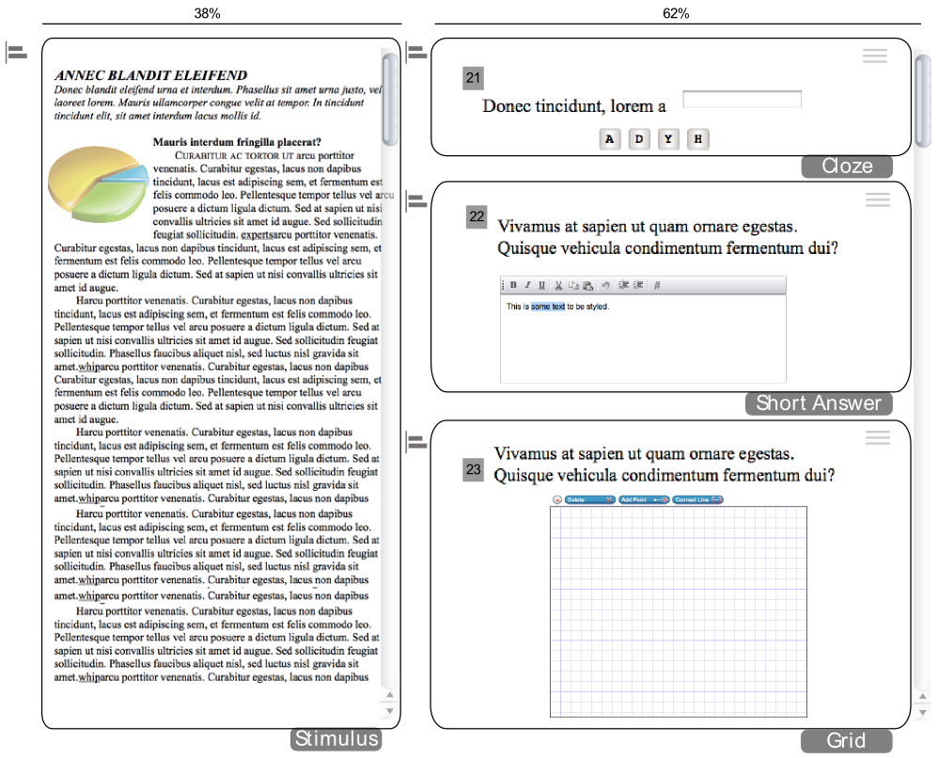

## Layout 25

Layout 25 occupies 100% of a user’s screen, dividing it 30/70 horizontally between a passage and sets of items. There is slightly less white space, or padding, between the left and right edges of each column—10 pixels on each side instead of the normal 20 pixels. At the default zoom level, Layout 25 is wide enough to accommodate Grid, Simulation, and Scratch Pad items without a horizontal scroll bar.

Layout 25: Multiple Item Types

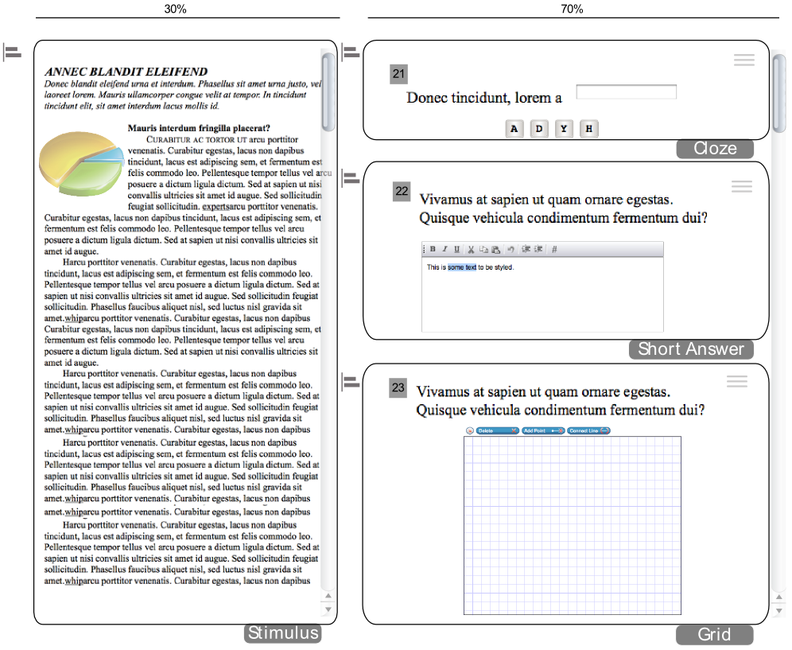

## Layout 26

Layout 26 occupies 100% of a user’s screen, dividing it 50/50 horizontally between a passage and sets of items. There is slightly less white space, or padding, between the left and right edges of each column—10 pixels on each side instead of the normal 20 pixels. **At the default zoom level on a smaller sized monitor, the item column in Layout 26 would require a horizontal scroll bar to accommodate Grid, Simulation, or Scratch Pad items.**

Layout 26: Multiple Item Types

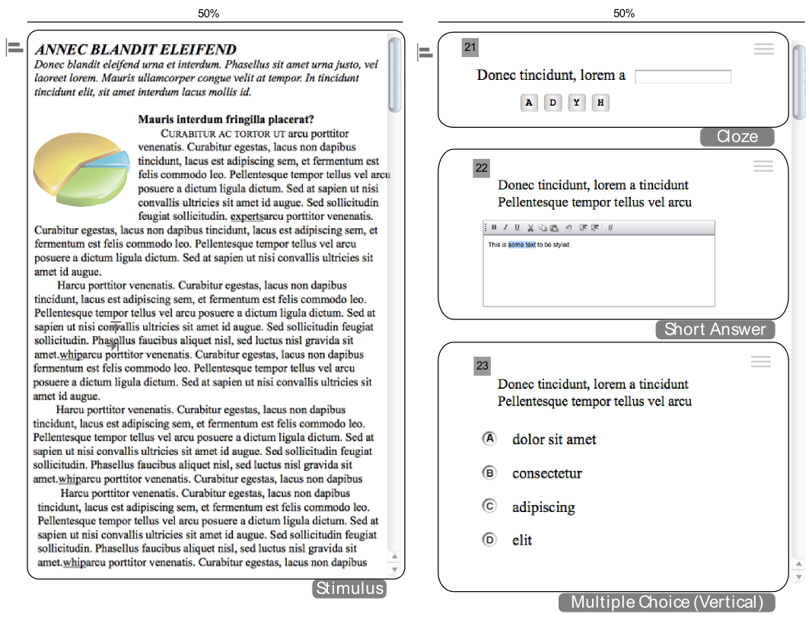

## Layout 27 & 28

Layout 27 occupies 100% of a user’s screen, dividing it 70/30 horizontally between a passage and sets of items. There is slightly less white space, or padding, between the left and right edges of each column—10 pixels on each side instead of the normal 20 pixels. **At the default zoom level on a smaller sized monitor, the item column in Layout 27 would require a horizontal scroll bar to accommodate Grid, Simulation, or Scratch Pad items.**

Layout 28 is similar, but uses a Simulation item instead of a text passage in the left pane.

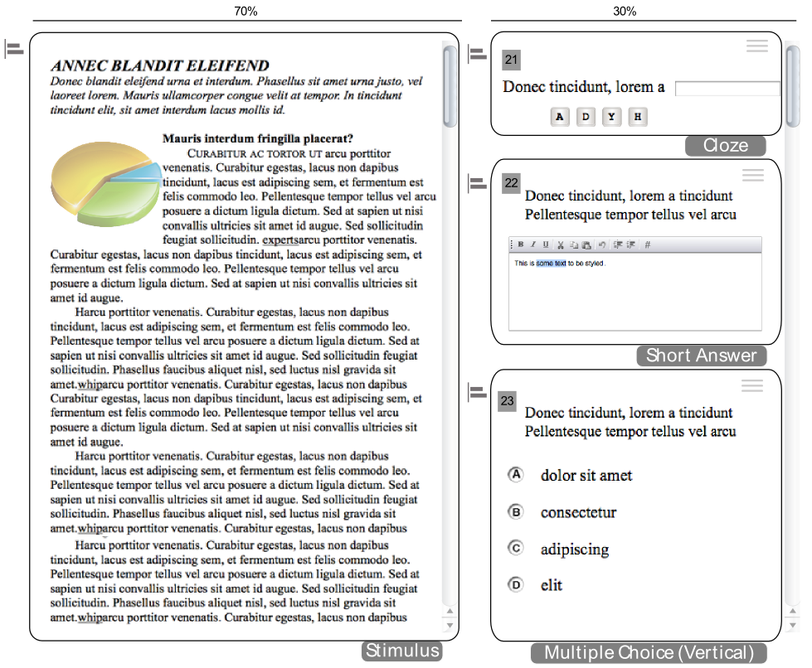

## Layout 30

Layout 30 does not have a maximum width. The Simulation item is 650 pixels tall and fills the remainder of the screen not occupied by the stem. The stem is 290 pixels wide.

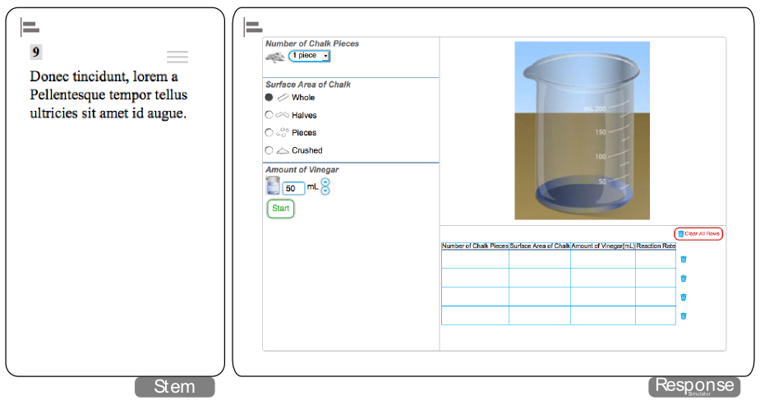

## Layout 31

Layout 31 does not have a maximum width. The Simulation item, located below the stem, is 650 pixels tall and fills the width of the screen. The stem fills the width of the screen and can be any height.

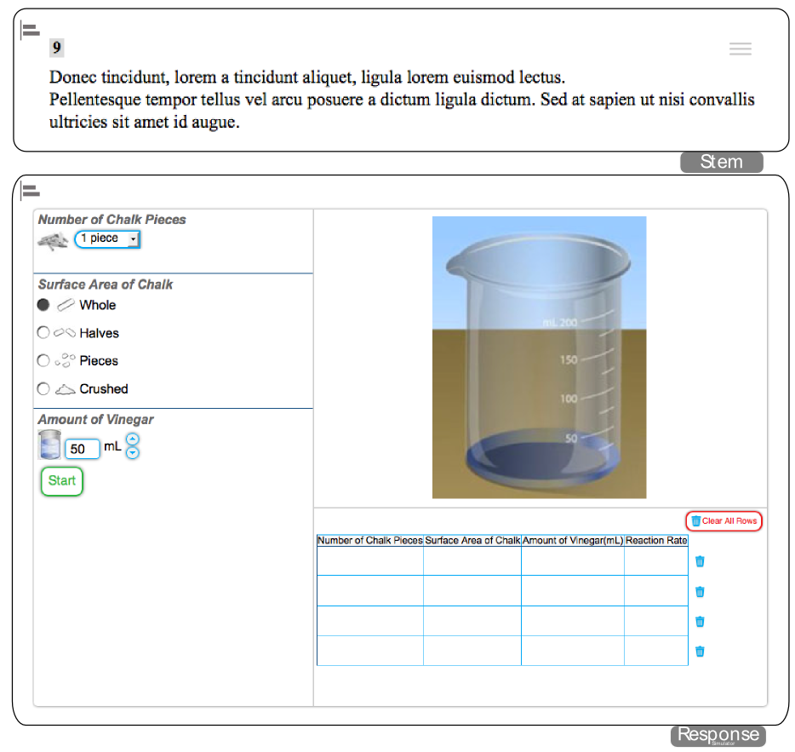

## Layout 32 & 33

Layout 32 occupies 100% of a user’s screen, with 20 pixels of white space, or padding, on all sides. This layout accommodates multiple items but no passage.

Layout 33 is similar, but supports Grid items.

Layout 33: Multiple Item Types

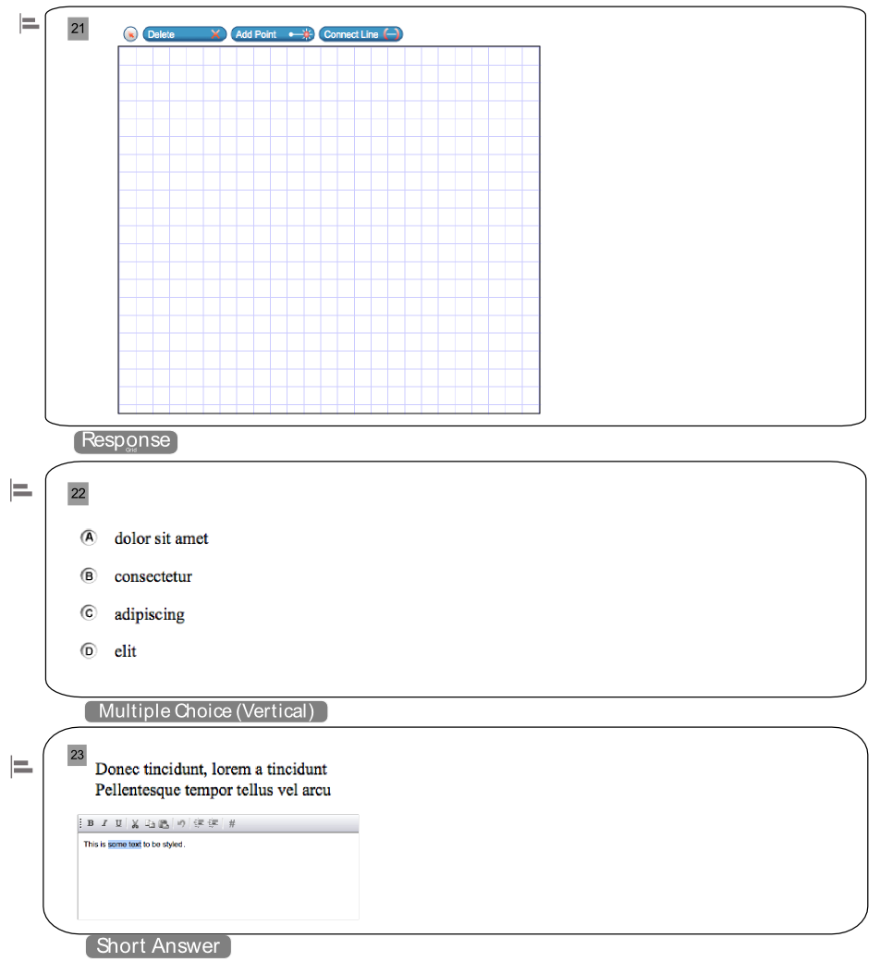

## Compound Layout 1

Compound Layout 1 fits to the window and is used with Edit Task and Hot Text items. It can contain several items simultaneously and is designed to mimic a single item in Layout 8.

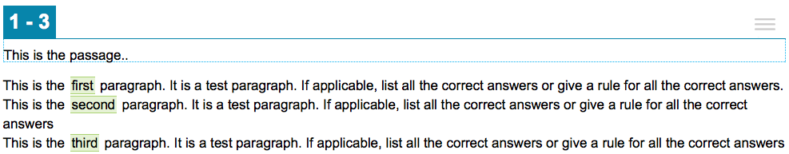

## Layout WAI

TDS converts each item’s original layout to Layout WAI automatically when a student tests in Streamlined Mode. Layout WAI occupies 100% of the screen and consists of a single column. This layout accommodates a single item per page, or multiple items (with or without a passage).

If a passage is included, it has no set height and uses the same scroll bar as the rest of the test page. All of the components on the page are listed vertically, with the passage on top and the items below it. If an item includes an illustration, it appears above the stem and response area.

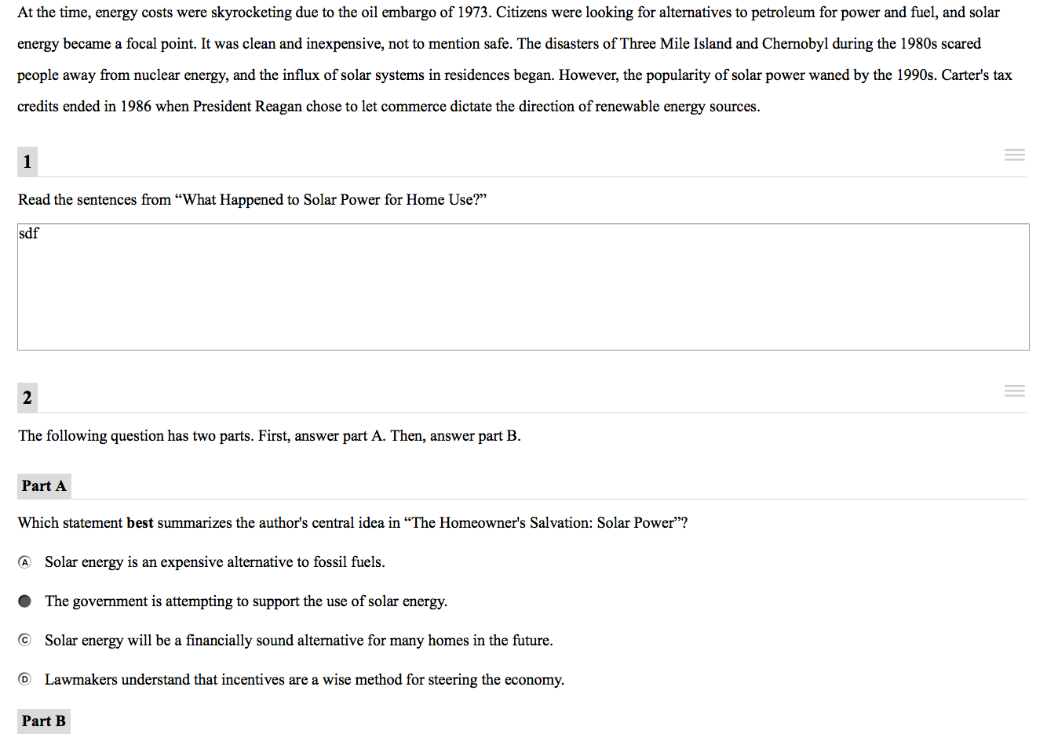

# Best Practices

This section provides basic guidelines to follow when selecting layouts.

## Best Practices 1: Use Appropriate Layout (Part I)

Do not use a multi-column layout (such as Layouts 17 or 21) for a single item when Layout 1 will work.

|  |  |
| --- | --- |
| Layout 1 | Layout 17 |

## Best Practices 2: Use Appropriate Layout (Part II)

Do not use Layout 6 for an item that is not associated with a stimulus. Use Layout 8 for such items instead.

|  |  |
| --- | --- |
| Figure . Layout 6 | Figure . Layout 8 |

## Best Practices 3: Use Small Images for Response Options

When working with images for Picture-Click items, try to use small dimensions (less than 150 pixels wide by 100 pixels tall). On smaller screens, or in multi-column layouts, using a wide image in options may require students to scroll.

|  |  |
| --- | --- |
| Picture-Click Item | Picture-Click Item with Wide Image |

## Best Practices 4: Separate Text from Graphics

Whenever possible, do not use graphics that contain text. Separate the graphic as an independent image and the text as actual text. For example, do not use an entire poem or newspaper clipping as a graphic. Screen-readers and text-to-speech cannot make much sense of the content without the text.

|  |  |
| --- | --- |
| Graphic Containing Text | Graphic Separated from Text |

## Best Practices 5: Use Caution When Working with Tables

HTML tables are preferable to large images of tables, but be careful of setting styles within the table, such as adding a background color to a table cell. Added styles may have unintended consequences when students test with accommodations, such as color-overlay. Additionally, when a student with a high zoom level sends a print request, the table will most likely get cropped, leaving some of the content inaccessible to them.

Table with High Zoom Level

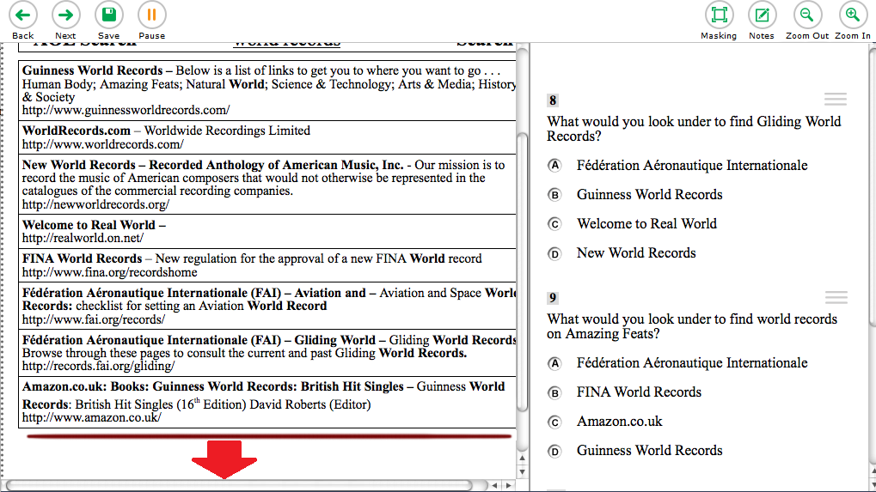

## Best Practices 6: Use Caution When Adjusting Spacing

Be very careful when adjusting spacing. Adding extra spaces before a response option or at the end of a sentence or paragraph can have unpredictable consequences with text wrapping. Things may look fine on one screen, but on a larger or smaller screen a line may break awkwardly as a result of extra blank spaces.

|  |  |
| --- | --- |
| Passage with Extra Spacing | Passage Without Extra Spacing |

## Best Practices 7: Use Appropriate Tags

Use the <em> tag to emphasize something; use the <i> tag to just make something italic. A screen-reader can convey emphasis when reading aloud, but it cannot convey italics.

## Best Practices 8: Avoid Underlining Text

When text is presented on screen, underlined words typically indicate clickable hyperlinks. This could confuse students.

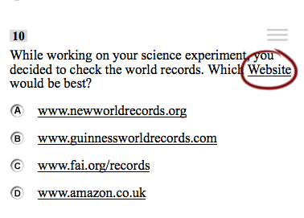

## Best Practices 9: Align Images in Response Options

When working with items that have single images as a response option (often in math), add a non-breaking space after the image to maintain proper vertical alignment.

|  |  |
| --- | --- |
|  |  |

# Cover Page Layouts

Cover pages contain no interactive elements, and are used to instruct students taking tests. Cover pages consist of a stem, illustration, or both—but no response section. A border surrounds the cover page content, which is approximately 800px wide and as tall as the content requires. All cover pages, except for Cover Page 1, place the beginning of the content about 5% below the top of the content area. Text size is set automatically to zoom level 4. Because text sizes are much larger than default, it is important to keep the content of the stem as short as possible (10 words or fewer).

## Cover Page 1

Cover Page 1 contains just a stem. It is different from the rest of the cover pages in that it starts further down a student’s screen, so that it appears vertically centered if there are two lines of text (one line of text appears slightly above center).

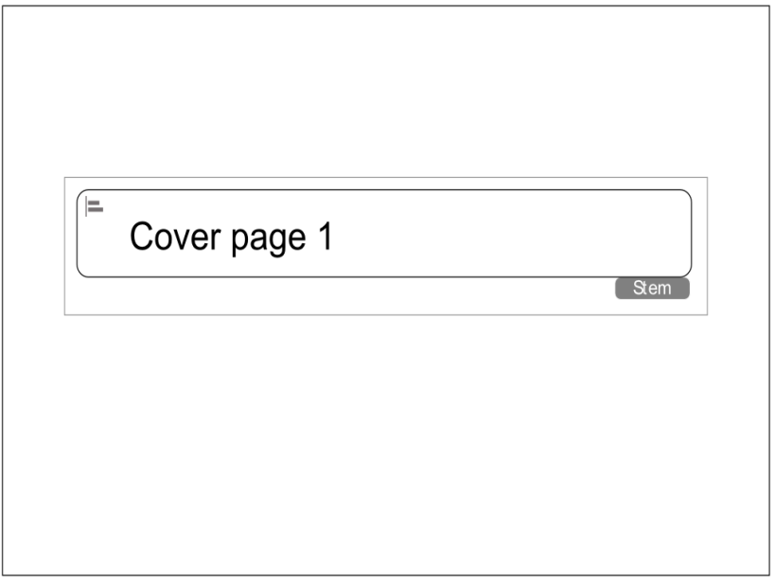

## Cover Page 2

Cover Page 2 contains a stem on top and an illustration below it. In order for all content to be visible without a scrollbar, a maximum height of 200 pixels is recommended for images.

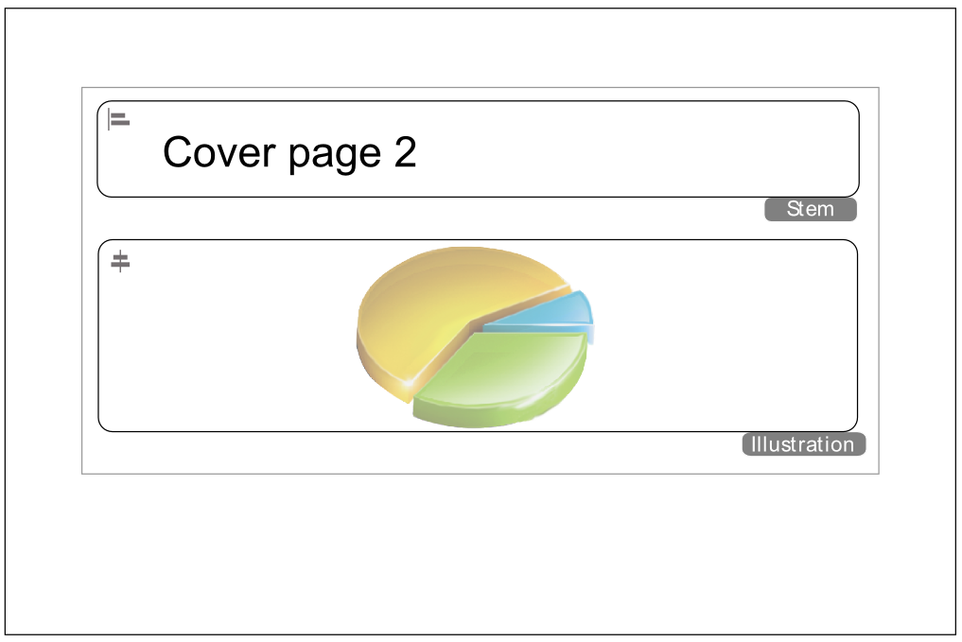

## Cover Page 3

Cover Page 3 contains an illustration on top and a stem below it. In order for all content to be visible without a scrollbar, a maximum height of 200 pixels is recommended for images.

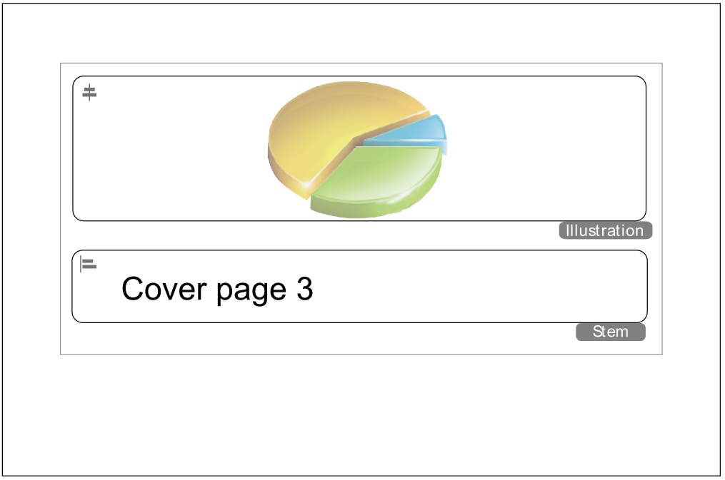

## Cover Page 4

Cover Page 4 contains a stem on the left, and an illustration on the right. It is important for the illustration to be no more than 350 pixels tall and 350 pixels wide, or else the illustration displays below the stem.

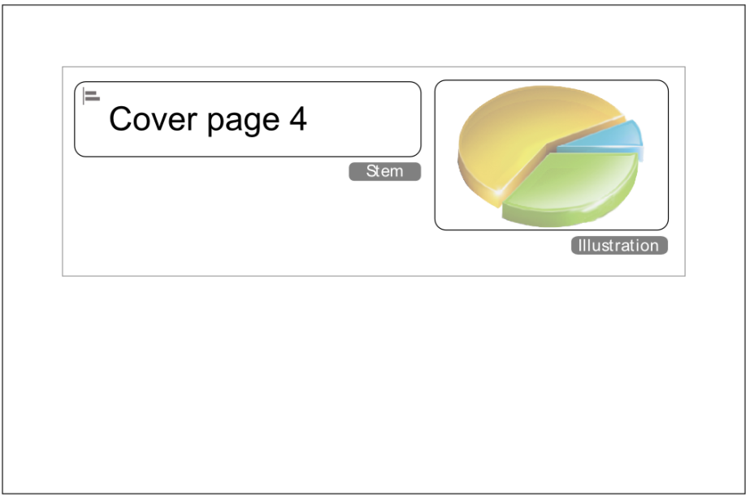

## Cover Page 5

Cover Page 5 contains an illustration on the left, and a stem on the right. It is important for the illustration to be no taller than 350 pixels and 350 pixels wide, or else the stem displays below the illustration.

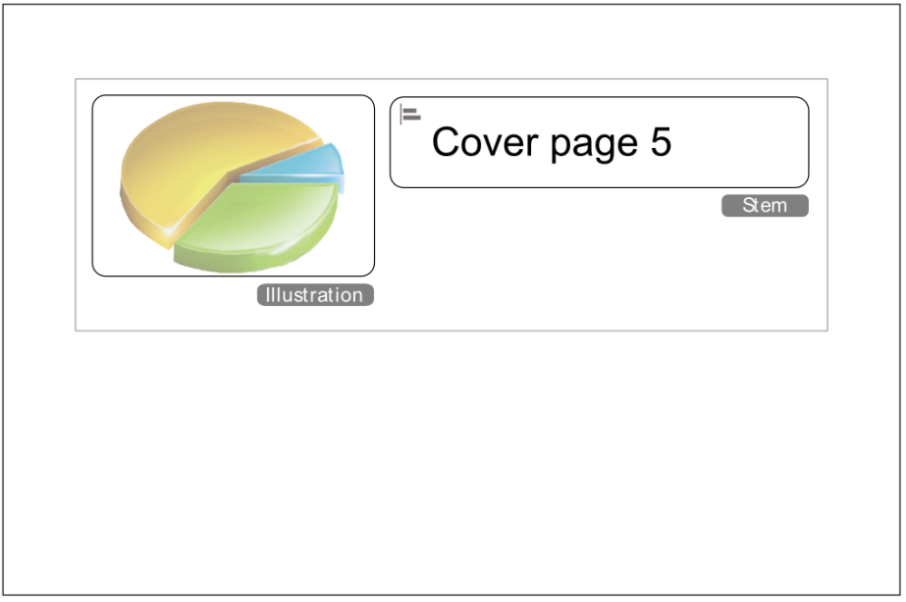

## Cover Page 6

Cover page 6 is simply an illustration.

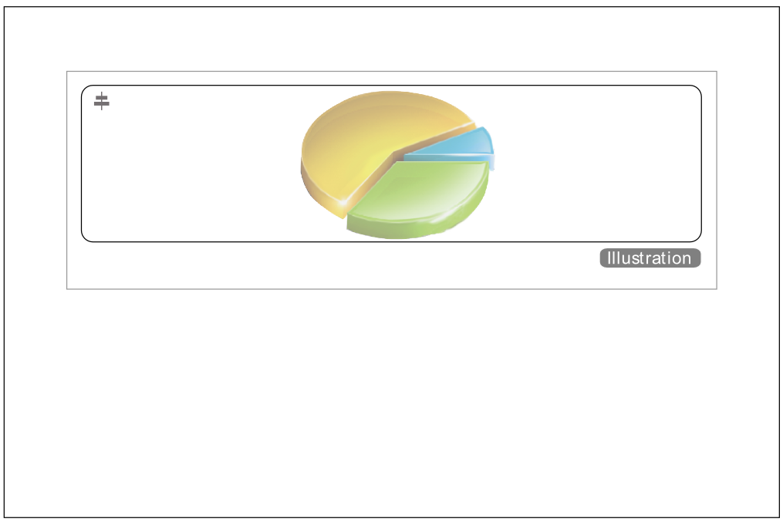

# Maximum Image Dimensions

The table below shows the maximum dimensions of an image (in pixels) you can use in a particular layout without forcing students to scroll to see all of an item’s content on a standard 1024x768 monitor (the smallest size we support).

For layouts with passages, the first set of dimensions (yellow) is the space available for an image if it’s embedded in the stem of an item. The second set of dimensions (green) is for images placed inside the passage (stimulus) area.

|  |  |  |  |  |
| --- | --- | --- | --- | --- |
|  | **Stem Max Image Width** | **Stem Max Image Height** | **Passage Max Image Width** | **Passage Max Image Height** |
| **Layout 1** | 600 | 590 |  |  |
| **Layout 2** | 400 | 450 |  |  |
| **Layouts 3 & 4** | 400 | 450 |  |  |
| **Layout 5** | 600 | 400 |  |  |
| **Layout 6** | 600 | 400 |  |  |
| **Layout 8** |  |  |  |  |
| **Layout 12** |  |  |  |  |
| **Layout 13** |  |  |  |  |
| **Layout 14** | 600 | 450 |  |  |
| **Layout 15** |  |  |  |  |
| **Layouts 11 & 17** | 360 | 250 | 590 | 590 |
| **Layout 21** | 570 | 250 | 400 | 590 |
| **Layout 22** |  |  |  |  |
| **Layout 23** | 960 | 250 | 980 | 250 |
| **Layout 24 & 29** | 600 | 250 | 380 | 590 |
| **Layout 25** | 670 | 250 | 290 | 590 |
| **Layout 26** | 470 | 250 | 500 | 590 |
| **Layout 27 & 28** | 270 | 250 | 700 | 590 |
| **Layout 32 & 33** | 960 | 700 |  |  |
| **Layout WAI** | 960 | 700 | 960 | 700 |